Bank Marketing Case Study

Collin Real, Leonel Salazar, Seth Harris, Joaquin Ramirez

library(tidyverse)

Warning: package 'ggplot2' was built under R version 4.3.3

Warning: package 'tidyr' was built under R version 4.3.3

Warning: package 'dplyr' was built under R version 4.3.3

Warning: package 'stringr' was built under R version 4.3.2

Warning: package 'lubridate' was built under R version 4.3.2

── Attaching core tidyverse packages ──────────────────────── tidyverse 2.0.0 ──  
✔ dplyr 1.1.4 ✔ readr 2.1.4  
✔ forcats 1.0.0 ✔ stringr 1.5.1  
✔ ggplot2 3.5.1 ✔ tibble 3.2.1  
✔ lubridate 1.9.3 ✔ tidyr 1.3.1  
✔ purrr 1.0.2   
── Conflicts ────────────────────────────────────────── tidyverse_conflicts() ──  
✖ dplyr::filter() masks stats::filter()  
✖ dplyr::lag() masks stats::lag()  
ℹ Use the conflicted package (<http://conflicted.r-lib.org/>) to force all conflicts to become errors

library(ggplot2)  
library(here)

Warning: package 'here' was built under R version 4.3.3

here() starts at C:/Users/Leonel/Desktop/MSDA/MS Data Analytics/Current Class/DA 6813/Week 3/Case Study Banking

library(caret)

Warning: package 'caret' was built under R version 4.3.3

Loading required package: lattice

Warning: package 'lattice' was built under R version 4.3.3

Attaching package: 'caret'  
  
The following object is masked from 'package:purrr':  
  
 lift

library(dplyr)  
library(stats)  
library(car)

Loading required package: carData  
  
Attaching package: 'car'  
  
The following object is masked from 'package:dplyr':  
  
 recode  
  
The following object is masked from 'package:purrr':  
  
 some

library(pscl)

Warning: package 'pscl' was built under R version 4.3.3

Classes and Methods for R originally developed in the  
Political Science Computational Laboratory  
Department of Political Science  
Stanford University (2002-2015),  
by and under the direction of Simon Jackman.  
hurdle and zeroinfl functions by Achim Zeileis.

library(flextable)

Warning: package 'flextable' was built under R version 4.3.3

Attaching package: 'flextable'  
  
The following object is masked from 'package:purrr':  
  
 compose

library(corrplot)

Warning: package 'corrplot' was built under R version 4.3.3

corrplot 0.94 loaded

library(pROC)

Warning: package 'pROC' was built under R version 4.3.3

Type 'citation("pROC")' for a citation.  
  
Attaching package: 'pROC'  
  
The following objects are masked from 'package:stats':  
  
 cov, smooth, var

library(randomForest)

Warning: package 'randomForest' was built under R version 4.3.3

randomForest 4.7-1.1  
Type rfNews() to see new features/changes/bug fixes.  
  
Attaching package: 'randomForest'  
  
The following object is masked from 'package:dplyr':  
  
 combine  
  
The following object is masked from 'package:ggplot2':  
  
 margin

# Use the here function to construct the file path and import the dataset  
data <- read.csv(here("bank-additional_clean.csv"), header = TRUE, sep = ",")  
  
# View the first few rows of the dataset  
head(data)

age job marital education default housing loan contact  
1 30 blue-collar married basic.9y no yes no cellular  
2 39 services single high.school no no no telephone  
3 25 services married high.school no yes no telephone  
4 38 services married basic.9y no unknown unknown telephone  
5 47 admin. married university.degree no yes no cellular  
6 32 services single university.degree no no no cellular  
 month day_of_week duration campaign pdays previous poutcome emp.var.rate  
1 may fri 487 2 999 0 nonexistent -1.8  
2 may fri 346 4 999 0 nonexistent 1.1  
3 jun wed 227 1 999 0 nonexistent 1.4  
4 jun fri 17 3 999 0 nonexistent 1.4  
5 nov mon 58 1 999 0 nonexistent -0.1  
6 sep thu 128 3 999 2 failure -1.1  
 cons.price.idx cons.conf.idx euribor3m nr.employed y  
1 92.893 -46.2 1.313 5099.1 no  
2 93.994 -36.4 4.855 5191.0 no  
3 94.465 -41.8 4.962 5228.1 no  
4 94.465 -41.8 4.959 5228.1 no  
5 93.200 -42.0 4.191 5195.8 no  
6 94.199 -37.5 0.884 4963.6 no

str(data)

'data.frame': 4119 obs. of 21 variables:  
 $ age : int 30 39 25 38 47 32 32 41 31 35 ...  
 $ job : chr "blue-collar" "services" "services" "services" ...  
 $ marital : chr "married" "single" "married" "married" ...  
 $ education : chr "basic.9y" "high.school" "high.school" "basic.9y" ...  
 $ default : chr "no" "no" "no" "no" ...  
 $ housing : chr "yes" "no" "yes" "unknown" ...  
 $ loan : chr "no" "no" "no" "unknown" ...  
 $ contact : chr "cellular" "telephone" "telephone" "telephone" ...  
 $ month : chr "may" "may" "jun" "jun" ...  
 $ day_of_week : chr "fri" "fri" "wed" "fri" ...  
 $ duration : int 487 346 227 17 58 128 290 44 68 170 ...  
 $ campaign : int 2 4 1 3 1 3 4 2 1 1 ...  
 $ pdays : int 999 999 999 999 999 999 999 999 999 999 ...  
 $ previous : int 0 0 0 0 0 2 0 0 1 0 ...  
 $ poutcome : chr "nonexistent" "nonexistent" "nonexistent" "nonexistent" ...  
 $ emp.var.rate : num -1.8 1.1 1.4 1.4 -0.1 -1.1 -1.1 -0.1 -0.1 1.1 ...  
 $ cons.price.idx: num 92.9 94 94.5 94.5 93.2 ...  
 $ cons.conf.idx : num -46.2 -36.4 -41.8 -41.8 -42 -37.5 -37.5 -42 -42 -36.4 ...  
 $ euribor3m : num 1.31 4.86 4.96 4.96 4.19 ...  
 $ nr.employed : num 5099 5191 5228 5228 5196 ...  
 $ y : chr "no" "no" "no" "no" ...

# Function to check for missing (NA) values and "unknown" entries in all columns  
check_missing_unknown <- function(data) {  
 result <- data.frame(  
 Variable = colnames(data),  
 Missing_Count = sapply(data, function(x) sum(is.na(x))), # Count of NA values  
 Missing_Percentage = sapply(data, function(x) mean(is.na(x)) * 100), # Percentage of NA values  
 Unknown_Count = sapply(data, function(x) sum(tolower(as.character(x)) == "unknown", na.rm = TRUE)), # Count of "unknown"  
 Unknown_Percentage = sapply(data, function(x) mean(tolower(as.character(x)) == "unknown", na.rm = TRUE) * 100) # Percentage of "unknown"  
 )  
 return(result)  
}  
  
  
missing_unknown_summary <- check_missing_unknown(data)  
  
# Display the summary table  
print(missing_unknown_summary)

Variable Missing_Count Missing_Percentage Unknown_Count  
age age 0 0 0  
job job 0 0 39  
marital marital 0 0 11  
education education 0 0 167  
default default 0 0 803  
housing housing 0 0 105  
loan loan 0 0 105  
contact contact 0 0 0  
month month 0 0 0  
day_of_week day_of_week 0 0 0  
duration duration 0 0 0  
campaign campaign 0 0 0  
pdays pdays 0 0 0  
previous previous 0 0 0  
poutcome poutcome 0 0 0  
emp.var.rate emp.var.rate 0 0 0  
cons.price.idx cons.price.idx 0 0 0  
cons.conf.idx cons.conf.idx 0 0 0  
euribor3m euribor3m 0 0 0  
nr.employed nr.employed 0 0 0  
y y 0 0 0  
 Unknown_Percentage  
age 0.0000000  
job 0.9468318  
marital 0.2670551  
education 4.0543821  
default 19.4950231  
housing 2.5491624  
loan 2.5491624  
contact 0.0000000  
month 0.0000000  
day_of_week 0.0000000  
duration 0.0000000  
campaign 0.0000000  
pdays 0.0000000  
previous 0.0000000  
poutcome 0.0000000  
emp.var.rate 0.0000000  
cons.price.idx 0.0000000  
cons.conf.idx 0.0000000  
euribor3m 0.0000000  
nr.employed 0.0000000  
y 0.0000000

# Convert all integer and numeric variables to numeric type  
data[] <- lapply(data, function(x) {  
 if (is.integer(x) || is.numeric(x)) {  
 return(as.numeric(x)) # Convert to numeric  
 } else if (is.character(x)) {  
 return(factor(x)) # Convert character to factor  
 } else {  
 return(x) # Leave other types unchanged  
 }  
})  
  
# Verify the changes  
str(data)

'data.frame': 4119 obs. of 21 variables:  
 $ age : num 30 39 25 38 47 32 32 41 31 35 ...  
 $ job : Factor w/ 12 levels "admin.","blue-collar",..: 2 8 8 8 1 8 1 3 8 2 ...  
 $ marital : Factor w/ 4 levels "divorced","married",..: 2 3 2 2 2 3 3 2 1 2 ...  
 $ education : Factor w/ 8 levels "basic.4y","basic.6y",..: 3 4 4 3 7 7 7 7 6 3 ...  
 $ default : Factor w/ 3 levels "no","unknown",..: 1 1 1 1 1 1 1 2 1 2 ...  
 $ housing : Factor w/ 3 levels "no","unknown",..: 3 1 3 2 3 1 3 3 1 1 ...  
 $ loan : Factor w/ 3 levels "no","unknown",..: 1 1 1 2 1 1 1 1 1 1 ...  
 $ contact : Factor w/ 2 levels "cellular","telephone": 1 2 2 2 1 1 1 1 1 2 ...  
 $ month : Factor w/ 10 levels "apr","aug","dec",..: 7 7 5 5 8 10 10 8 8 7 ...  
 $ day_of_week : Factor w/ 5 levels "fri","mon","thu",..: 1 1 5 1 2 3 2 2 4 3 ...  
 $ duration : num 487 346 227 17 58 128 290 44 68 170 ...  
 $ campaign : num 2 4 1 3 1 3 4 2 1 1 ...  
 $ pdays : num 999 999 999 999 999 999 999 999 999 999 ...  
 $ previous : num 0 0 0 0 0 2 0 0 1 0 ...  
 $ poutcome : Factor w/ 3 levels "failure","nonexistent",..: 2 2 2 2 2 1 2 2 1 2 ...  
 $ emp.var.rate : num -1.8 1.1 1.4 1.4 -0.1 -1.1 -1.1 -0.1 -0.1 1.1 ...  
 $ cons.price.idx: num 92.9 94 94.5 94.5 93.2 ...  
 $ cons.conf.idx : num -46.2 -36.4 -41.8 -41.8 -42 -37.5 -37.5 -42 -42 -36.4 ...  
 $ euribor3m : num 1.31 4.86 4.96 4.96 4.19 ...  
 $ nr.employed : num 5099 5191 5228 5228 5196 ...  
 $ y : Factor w/ 2 levels "no","yes": 1 1 1 1 1 1 1 1 1 1 ...

# Transform the 'pdays' column  
data_clean <- data %>%  
 mutate(pdays = ifelse(pdays == 999, "not previously contacted", "previously contacted"))  
  
# Convert 'pdays' to a factor  
data_clean$pdays <- as.factor(data_clean$pdays)  
  
# Display the first few rows to verify the change  
head(data_clean)

age job marital education default housing loan contact  
1 30 blue-collar married basic.9y no yes no cellular  
2 39 services single high.school no no no telephone  
3 25 services married high.school no yes no telephone  
4 38 services married basic.9y no unknown unknown telephone  
5 47 admin. married university.degree no yes no cellular  
6 32 services single university.degree no no no cellular  
 month day_of_week duration campaign pdays previous  
1 may fri 487 2 not previously contacted 0  
2 may fri 346 4 not previously contacted 0  
3 jun wed 227 1 not previously contacted 0  
4 jun fri 17 3 not previously contacted 0  
5 nov mon 58 1 not previously contacted 0  
6 sep thu 128 3 not previously contacted 2  
 poutcome emp.var.rate cons.price.idx cons.conf.idx euribor3m nr.employed  
1 nonexistent -1.8 92.893 -46.2 1.313 5099.1  
2 nonexistent 1.1 93.994 -36.4 4.855 5191.0  
3 nonexistent 1.4 94.465 -41.8 4.962 5228.1  
4 nonexistent 1.4 94.465 -41.8 4.959 5228.1  
5 nonexistent -0.1 93.200 -42.0 4.191 5195.8  
6 failure -1.1 94.199 -37.5 0.884 4963.6  
 y  
1 no  
2 no  
3 no  
4 no  
5 no  
6 no

# Remove the 'duration' variable  
data_clean <- select(data_clean, -duration)  
  
# Save the cleaned dataset as a new CSV file  
write.csv(data_clean, "data_clean.csv", row.names = FALSE)  
  
# Verify the dataset has been saved  
file.exists("data_clean.csv")

[1] TRUE

# Export the dataset to a CSV file in the same location  
write_csv(data, here("data_new.csv"))  
  
# Confirm the file is saved by showing the file path  
cat("Data has been exported to:", here("data_new.csv"))

Data has been exported to: C:/Users/Leonel/Desktop/MSDA/MS Data Analytics/Current Class/DA 6813/Week 3/Case Study Banking/data_new.csv

# Check the distribution of the target variable 'y'  
table(data$y)

no yes   
3668 451

# Calculate the percentage distribution of 'y'  
prop.table(table(data$y)) * 100

no yes   
89.05074 10.94926

# Function to count "unknown" values in each column  
count_unknowns <- function(df) {  
 sapply(df, function(x) sum(x == "unknown", na.rm = TRUE))  
}  
  
# Apply the function to the dataset  
unknown_counts <- count_unknowns(data)  
  
# Display the counts  
print(unknown_counts)

age job marital education default   
 0 39 11 167 803   
 housing loan contact month day_of_week   
 105 105 0 0 0   
 duration campaign pdays previous poutcome   
 0 0 0 0 0   
 emp.var.rate cons.price.idx cons.conf.idx euribor3m nr.employed   
 0 0 0 0 0   
 y   
 0

# Calculate the total number of "unknown" values across all variables  
total_unknowns <- sum(unknown_counts)  
print(paste("Total number of 'unknown' values across all variables:", total_unknowns))

[1] "Total number of 'unknown' values across all variables: 1230"

# Check for NA values in each column  
na_counts <- sapply(data, function(x) sum(is.na(x)))  
  
# Display the counts of NA values for each column  
print(na_counts)

age job marital education default   
 0 0 0 0 0   
 housing loan contact month day_of_week   
 0 0 0 0 0   
 duration campaign pdays previous poutcome   
 0 0 0 0 0   
 emp.var.rate cons.price.idx cons.conf.idx euribor3m nr.employed   
 0 0 0 0 0   
 y   
 0

# Calculate the total number of NA values across all columns  
total_na <- sum(na_counts)  
print(paste("Total number of NA values across all columns:", total_na))

[1] "Total number of NA values across all columns: 0"

# Up-sample the minority class  
set.seed(123) # For reproducibility  
data_clean_upsampled <- upSample(x = data_clean %>% select(-y), y = data_clean$y) # 'y' is the target variable  
  
# Check the new class distribution  
table(data_clean_upsampled$Class)

no yes   
3668 3668

# Down-sample the majority class  
set.seed(123) # For reproducibility  
data_clean_downsampled <- downSample(x = data_clean %>% select(-y), y = data_clean$y) # 'y' is the target variable  
  
# Check the new class distribution  
table(data_clean_downsampled$Class)

no yes   
451 451

# Load necessary libraries  
library(dplyr)  
  
  
  
# Calculate the count of "unknown" values for each column  
unknown_counts <- sapply(data_clean_downsampled, function(x) sum(x == "unknown", na.rm = TRUE))  
  
# Convert the counts to a data frame for better visualization  
unknown_counts_df <- data.frame(  
 Variable = names(unknown_counts),  
 Unknown_Count = unknown_counts  
)  
  
# Calculate the proportion of "unknown" values for each column  
unknown_counts_df <- unknown_counts_df %>%  
 mutate(Total_Count = nrow(data_clean_downsampled), # Total rows in the dataset  
 Unknown_Proportion = Unknown_Count / Total_Count * 100) # Proportion in percentage  
  
# Display the data frame with counts and proportions  
print(unknown_counts_df)

Variable Unknown_Count Total_Count Unknown_Proportion  
age age 0 902 0.0000000  
job job 6 902 0.6651885  
marital marital 1 902 0.1108647  
education education 40 902 4.4345898  
default default 141 902 15.6319290  
housing housing 20 902 2.2172949  
loan loan 20 902 2.2172949  
contact contact 0 902 0.0000000  
month month 0 902 0.0000000  
day_of_week day_of_week 0 902 0.0000000  
campaign campaign 0 902 0.0000000  
pdays pdays 0 902 0.0000000  
previous previous 0 902 0.0000000  
poutcome poutcome 0 902 0.0000000  
emp.var.rate emp.var.rate 0 902 0.0000000  
cons.price.idx cons.price.idx 0 902 0.0000000  
cons.conf.idx cons.conf.idx 0 902 0.0000000  
euribor3m euribor3m 0 902 0.0000000  
nr.employed nr.employed 0 902 0.0000000  
Class Class 0 902 0.0000000

# Calculate the overall percentage of "unknown" values across all variables  
total_unknowns <- sum(unknown_counts)  
total_values <- nrow(data_clean_downsampled) * ncol(data_clean_downsampled) # Total number of data points  
overall_unknown_percentage <- (total_unknowns / total_values) * 100  
  
print(paste("Overall percentage of 'unknown' values in the dataset:", round(overall_unknown_percentage, 2), "%"))

[1] "Overall percentage of 'unknown' values in the dataset: 1.26 %"

# Remove rows with 'unknown' values  
data_clean_downsampled_no_unknown <- data_clean_downsampled %>%  
 filter_all(~ . != "unknown")  
  
# Check the new size of the dataset  
print(dim(data_clean_downsampled_no_unknown))

[1] 708 20

# Load necessary libraries  
library(dplyr)  
  
# Remove rows with 'unknown' values from the downsampled data  
data_clean_downsampled_no_unknown <- data_clean_downsampled %>%  
 filter_all(~ . != "unknown")  
  
# Check the distribution of the target variable 'y' after removing unknowns  
balance_after_cleaning <- table(data_clean_downsampled_no_unknown$Class) # Assuming 'Class' is the name of the target variable column  
  
# Print the class balance  
print(balance_after_cleaning)

no yes   
338 370

# Calculate and display the proportion of each class  
balance_proportion <- prop.table(balance_after_cleaning) * 100  
print(balance_proportion)

no yes   
47.74011 52.25989

# Export the dataset to a CSV file in the same location  
write_csv(data, here("data_clean_downsampled_no_unknown .csv"))  
  
# Confirm the file is saved by showing the file path  
cat("Data has been exported to:", here("data_clean_downsampled_no_unknown .csv"))

Data has been exported to: C:/Users/Leonel/Desktop/MSDA/MS Data Analytics/Current Class/DA 6813/Week 3/Case Study Banking/data_clean_downsampled_no_unknown .csv

df <- data_clean_downsampled_no_unknown  
  
  
# Rename the column 'Class' to 'y'  
df <- df %>% rename(y = Class)  
  
# Identify categorical and numeric variables  
variables <- names(df)  
var_types <- ifelse(sapply(df, is.numeric), "Numeric", "Categorical")  
  
# Create a data frame to store variable names and their types  
var_table <- data.frame(Variable = variables, Type = var_types)  
  
# Create a flextable  
flex_table <- flextable(var_table)  
  
# Apply custom formatting:  
# Highlight "Categorical" types with light blue, and "Numeric" types with light pink  
flex_table <- flextable::bg(flex_table, j = "Type", i = ~ Type == "Categorical", bg = "lightblue") # Highlight categorical  
flex_table <- flextable::bg(flex_table, j = "Type", i = ~ Type == "Numeric", bg = "lightpink") # Highlight numeric  
  
# Adjust column widths for better readability  
flex_table <- autofit(flex_table)  
  
# Display the flextable  
flex_table

| Variable | Type |
| --- | --- |
| age | Numeric |
| job | Categorical |
| marital | Categorical |
| education | Categorical |
| default | Categorical |
| housing | Categorical |
| loan | Categorical |
| contact | Categorical |
| month | Categorical |
| day_of_week | Categorical |
| campaign | Numeric |
| pdays | Categorical |
| previous | Numeric |
| poutcome | Categorical |
| emp.var.rate | Numeric |
| cons.price.idx | Numeric |
| cons.conf.idx | Numeric |
| euribor3m | Numeric |
| nr.employed | Numeric |
| y | Categorical |

# Set up a 3x3 plotting area  
par(mfrow=c(3,3))  
  
# Identify categorical variables (factor or character type)  
categorical_vars <- sapply(df, function(x) is.factor(x) | is.character(x))   
categorical_data <- df[, categorical_vars] # Subset the dataframe for categorical variables  
  
# Loop through all categorical variables and plot bar plots  
for (var in names(categorical_data)) {  
 barplot(table(categorical_data[[var]]), main=paste("Bar Plot of", var), xlab=var, col="lightblue")  
}

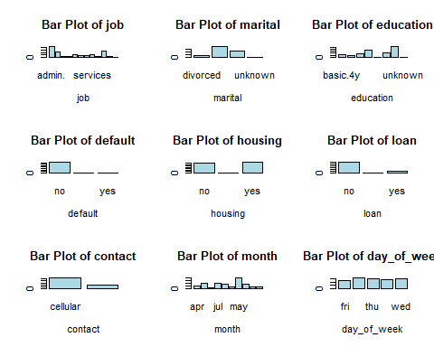

# Reset the plotting layout to 1x1 after plotting  
par(mfrow=c(1,1))

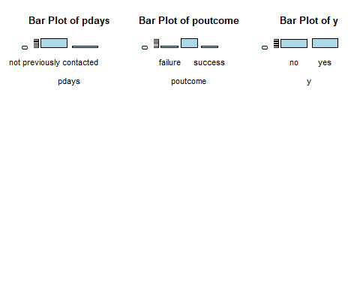

# Set up a 3x3 plotting area  
par(mfrow=c(3,3))  
  
# Loop through all the columns and plot histograms for continuous (numeric) variables  
numeric_vars <- sapply(df, is.numeric) # Identify numeric variables  
continuous_vars <- df[, numeric_vars] # Subset the dataframe for numeric variables  
  
# Plot histograms for each numeric variable  
for (var in names(continuous_vars)) {  
 hist(continuous_vars[[var]], main=paste("Histogram of", var), xlab=var, col="lightblue", breaks=20)  
}  
  
# Reset the plotting layout to 1x1 after plotting  
par(mfrow=c(1,1))

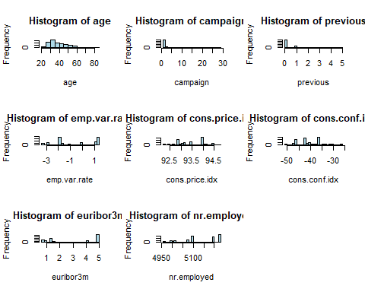

# Set up a 3x3 plotting area  
par(mfrow=c(1,2))  
  
# Identify numeric variables in the dataset  
numeric_vars <- sapply(df, is.numeric)  
  
# Subset the dataset to include only the numeric variables  
numeric_data <- df[, numeric_vars]  
  
# Loop through the numeric variables and create boxplots  
for (var in names(numeric_data)) {  
 boxplot(numeric_data[[var]], main=paste("Boxplot of", var), xlab=var, col="lightblue")  
}

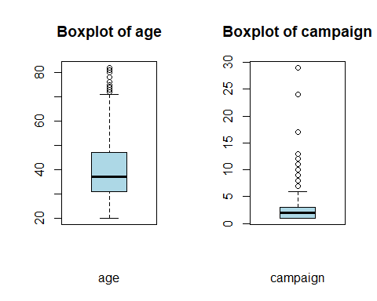

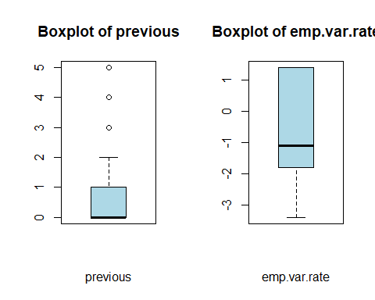

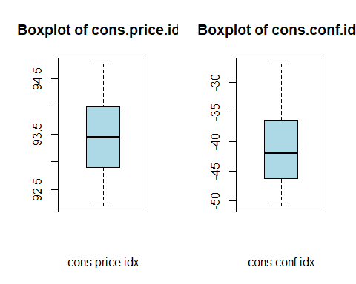

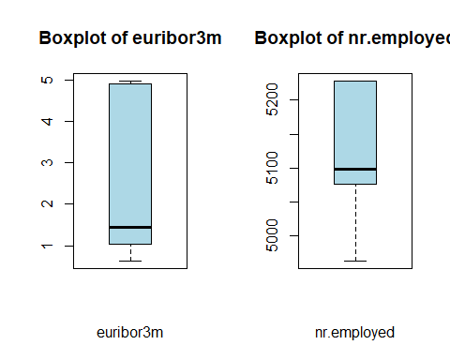

# Reset the plotting layout to 1x1 after plotting

library(corrplot)  
  
# Select only the numeric variables from the dataset  
numeric_vars <- df[, sapply(df, is.numeric)]  
  
# Create the correlation matrix  
cor_matrix <- cor(numeric_vars, use="complete.obs")  
  
# Visualize the correlation matrix  
corrplot(cor_matrix, method="circle", type="lower",   
 tl.col="black", tl.cex=0.8, title="Correlation Matrix of Numeric Variables",  
 mar=c(0,0,1,0))

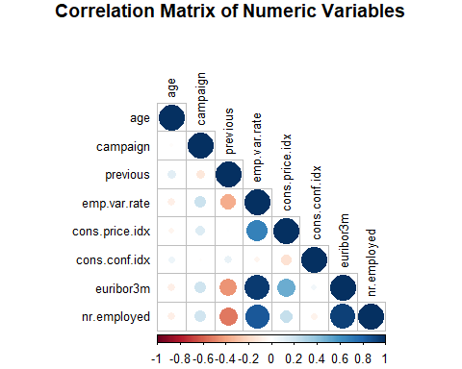

### Key Assumptions of Logistic Regression:

1. **Binary Outcome Variable**: The dependent variable should be binary.
2. **Independence of Observations**: Observations should be independent of each other.
3. **No Multicollinearity**: Predictor variables should not be highly correlated with each other.
4. **Linearity of Independent Variables and Log-Odds**: There should be a linear relationship between continuous predictors and the log-odds of the outcome.
5. **Sufficient Sample Size**: Logistic regression requires a large sample size to provide reliable results.

### Steps to Test the Assumptions

### 1. **Check for Binary Outcome Variable**

Ensure the dependent variable (y) is binary.

# Check the levels of the outcome variable  
table(df$y)

no yes   
338 370

# Check for variables with only one level  
lapply(df, function(x) length(unique(x)))

$age  
[1] 57  
  
$job  
[1] 11  
  
$marital  
[1] 3  
  
$education  
[1] 6  
  
$default  
[1] 1  
  
$housing  
[1] 2  
  
$loan  
[1] 2  
  
$contact  
[1] 2  
  
$month  
[1] 10  
  
$day_of_week  
[1] 5  
  
$campaign  
[1] 16  
  
$pdays  
[1] 2  
  
$previous  
[1] 6  
  
$poutcome  
[1] 3  
  
$emp.var.rate  
[1] 9  
  
$cons.price.idx  
[1] 25  
  
$cons.conf.idx  
[1] 25  
  
$euribor3m  
[1] 170  
  
$nr.employed  
[1] 10  
  
$y  
[1] 2

# Set a seed for reproducibility  
set.seed(123)  
  
# Split the data into training (70%) and testing (30%) sets  
trainIndex <- createDataPartition(df$y, p = 0.7, list = FALSE)  
train_data <- df[trainIndex, ] # 70% training data  
test_data <- df[-trainIndex, ] # 30% test data

# Fit the logistic regression model on the training set  
logit_model_train <- glm(y ~ age + job + marital + education + housing + loan + contact + month +   
 day_of_week + campaign + pdays + previous + poutcome + emp.var.rate +   
 cons.price.idx + cons.conf.idx,   
 family = binomial, data = train_data)  
  
# Display the summary of the model  
summary(logit_model_train)

Call:  
glm(formula = y ~ age + job + marital + education + housing +   
 loan + contact + month + day_of_week + campaign + pdays +   
 previous + poutcome + emp.var.rate + cons.price.idx + cons.conf.idx,   
 family = binomial, data = train_data)  
  
Coefficients:  
 Estimate Std. Error z value Pr(>|z|)   
(Intercept) -1.342e+02 4.230e+01 -3.173 0.00151 **   
age 2.352e-02 1.550e-02 1.517 0.12915   
jobblue-collar 8.347e-01 4.557e-01 1.832 0.06701 .   
jobentrepreneur 3.124e-01 6.185e-01 0.505 0.61350   
jobhousemaid 1.336e+00 1.152e+00 1.160 0.24621   
jobmanagement -7.618e-02 4.796e-01 -0.159 0.87381   
jobretired 1.304e+00 8.250e-01 1.580 0.11401   
jobself-employed -4.210e-01 6.558e-01 -0.642 0.52093   
jobservices -5.656e-01 4.996e-01 -1.132 0.25754   
jobstudent -1.258e-01 8.927e-01 -0.141 0.88795   
jobtechnician 1.738e-01 4.033e-01 0.431 0.66657   
jobunemployed 1.512e-01 7.141e-01 0.212 0.83230   
maritalmarried 6.065e-01 4.197e-01 1.445 0.14846   
maritalsingle 7.310e-01 4.766e-01 1.534 0.12512   
educationbasic.6y 3.549e-01 7.181e-01 0.494 0.62111   
educationbasic.9y 1.284e+00 5.783e-01 2.221 0.02634 *   
educationhigh.school 1.192e+00 6.134e-01 1.943 0.05196 .   
educationprofessional.course 1.194e+00 6.219e-01 1.920 0.05485 .   
educationuniversity.degree 1.553e+00 6.207e-01 2.502 0.01234 *   
housingyes 2.919e-01 2.410e-01 1.212 0.22566   
loanyes -6.605e-02 3.420e-01 -0.193 0.84685   
contacttelephone -6.444e-01 4.693e-01 -1.373 0.16971   
monthaug 4.551e-01 8.065e-01 0.564 0.57255   
monthdec 2.754e-01 1.188e+00 0.232 0.81662   
monthjul 3.580e-01 6.712e-01 0.533 0.59381   
monthjun 7.929e-01 6.693e-01 1.185 0.23610   
monthmar 2.391e+00 1.251e+00 1.911 0.05606 .   
monthmay -7.079e-01 5.004e-01 -1.415 0.15715   
monthnov -4.944e-01 6.472e-01 -0.764 0.44496   
monthoct 1.653e+00 1.233e+00 1.340 0.18026   
monthsep 1.605e-01 1.137e+00 0.141 0.88779   
day_of_weekmon -3.501e-01 3.949e-01 -0.887 0.37527   
day_of_weekthu -2.005e-01 4.011e-01 -0.500 0.61712   
day_of_weektue -1.484e-01 4.087e-01 -0.363 0.71648   
day_of_weekwed -1.408e-01 3.965e-01 -0.355 0.72251   
campaign -8.869e-02 6.204e-02 -1.429 0.15289   
pdayspreviously contacted -1.498e+00 1.377e+00 -1.087 0.27691   
previous 7.235e-01 7.206e-01 1.004 0.31541   
poutcomenonexistent 1.267e+00 8.877e-01 1.427 0.15357   
poutcomesuccess 3.616e+00 1.485e+00 2.436 0.01487 *   
emp.var.rate -9.018e-01 1.744e-01 -5.172 2.32e-07 ***  
cons.price.idx 1.394e+00 4.534e-01 3.074 0.00211 **   
cons.conf.idx 6.525e-03 4.144e-02 0.157 0.87488   
---  
Signif. codes: 0 '***' 0.001 '**' 0.01 '*' 0.05 '.' 0.1 ' ' 1  
  
(Dispersion parameter for binomial family taken to be 1)  
  
 Null deviance: 686.63 on 495 degrees of freedom  
Residual deviance: 460.44 on 453 degrees of freedom  
AIC: 546.44  
  
Number of Fisher Scoring iterations: 6

* **Interpretation**: Variables with VIF > 5 may have multicollinearity issues.

# Calculate VIF values for the logistic regression model  
vif_values_train <- vif(logit_model_train)  
  
# Print the VIF values  
print(vif_values_train)

GVIF Df GVIF^(1/(2*Df))  
age 1.995198 1 1.412515  
job 10.710825 10 1.125878  
marital 1.565157 2 1.118509  
education 4.635112 5 1.165752  
housing 1.101601 1 1.049572  
loan 1.129275 1 1.062673  
contact 2.898302 1 1.702440  
month 32.739111 9 1.213865  
day_of_week 1.514840 4 1.053285  
campaign 1.227187 1 1.107785  
pdays 6.690954 1 2.586688  
previous 10.419883 1 3.227984  
poutcome 26.906185 2 2.277524  
emp.var.rate 6.200906 1 2.490162  
cons.price.idx 5.618510 1 2.370340  
cons.conf.idx 3.210340 1 1.791742

# Example: Remove a variable with high VIF and refit the model  
logit_model_train_refit <- glm(y ~ age + job + marital + education + housing + loan + contact + month +   
 day_of_week + campaign + pdays + previous + poutcome + emp.var.rate +   
 cons.price.idx,   
 family = binomial, data = train_data)  
  
# Recheck VIF values for the refit model  
vif_values_refit <- vif(logit_model_train_refit)  
print(vif_values_refit)

GVIF Df GVIF^(1/(2*Df))  
age 1.976584 1 1.405911  
job 10.300156 10 1.123679  
marital 1.564170 2 1.118333  
education 4.576832 5 1.164277  
housing 1.101864 1 1.049697  
loan 1.115461 1 1.056154  
contact 2.000838 1 1.414510  
month 13.082882 9 1.153557  
day_of_week 1.502291 4 1.052190  
campaign 1.217553 1 1.103428  
pdays 6.595205 1 2.568113  
previous 10.384689 1 3.222528  
poutcome 26.745373 2 2.274114  
emp.var.rate 6.166751 1 2.483294  
cons.price.idx 5.643062 1 2.375513

# Check the number of events (e.g., 1's and 0's in the outcome variable)  
table(train_data$y)

no yes   
237 259

# Ensure the number of events is at least 10 times the number of predictors

# Predict probabilities for the training data using the logistic regression model  
predicted_probabilities_train <- predict(logit_model_train, newdata = train_data, type = "response")  
  
# Convert probabilities to binary outcome (using 0.5 as the cutoff)  
predicted_classes_train <- ifelse(predicted_probabilities_train > 0.5, 1, 0)  
  
# Create confusion matrix for training data  
confusion_matrix_train <- table(predicted_classes_train, train_data$y)  
print(confusion_matrix_train)

predicted_classes_train no yes  
 0 195 71  
 1 42 188

# Extract the values from the confusion matrix  
TN <- confusion_matrix_train[1,1] # True Negatives  
FP <- confusion_matrix_train[1,2] # False Positives  
FN <- confusion_matrix_train[2,1] # False Negatives  
TP <- confusion_matrix_train[2,2] # True Positives  
  
# Calculate accuracy  
accuracy_train <- (TP + TN) / sum(confusion_matrix_train)  
  
# Calculate precision, recall, and F1 score  
precision_train <- ifelse((TP + FP) > 0, TP / (TP + FP), 0) # TP / (TP + FP)  
recall_train <- ifelse((TP + FN) > 0, TP / (TP + FN), 0) # TP / (TP + FN)  
f1_score_train <- ifelse((precision_train + recall_train) > 0,   
 2 * ((precision_train * recall_train) / (precision_train + recall_train)),   
 0)  
  
# Print the performance metrics for the training data  
print(paste("Accuracy:", accuracy_train))

[1] "Accuracy: 0.772177419354839"

print(paste("Precision:", precision_train))

[1] "Precision: 0.725868725868726"

print(paste("Recall:", recall_train))

[1] "Recall: 0.817391304347826"

print(paste("F1 Score:", f1_score_train))

[1] "F1 Score: 0.768916155419223"

accuracy <- 0.7722   
precision <- 0.7259   
recall <- 0.8174   
f1_score <- 0.7689   
  
# Create a dataframe with the performance metrics  
metrics_data <- data.frame(  
 Metric = c("Accuracy", "Precision", "Recall", "F1 Score"),  
 Value = c(accuracy, precision, recall, f1_score)  
)  
  
  
  
# Create the flextable  
performance_table <- flextable(metrics_data)  
  
# Apply consistent styling to the flextable with alternating colors  
performance_table <- performance_table %>%  
 color(j = 1, color = "black") %>% # Text color for Metric column  
 color(j = 2, color = "darkblue") %>% # Text color for Value column  
 bg(part = "body", bg = "lightgray", i = ~ Metric == "Accuracy") %>% # Background color for Accuracy  
 bg(part = "body", bg = "lightblue", i = ~ Metric == "Precision") %>% # Background color for Precision  
 bg(part = "body", bg = "lightgray", i = ~ Metric == "Recall") %>% # Background color for Recall  
 bg(part = "body", bg = "lightblue", i = ~ Metric == "F1 Score") %>% # Background color for F1 Score  
 align(j = 2, align = "center", part = "body") %>% # Center-align the values  
 autofit() # Adjust column widths  
  
# Print the flextable  
performance_table

| Metric | Value |
| --- | --- |
| Accuracy | 0.7722 |
| Precision | 0.7259 |
| Recall | 0.8174 |
| F1 Score | 0.7689 |

# Predict probabilities for the training set using the logistic regression model  
predicted_probabilities_train <- predict(logit_model_train, newdata = train_data, type = "response")  
  
# Create the ROC curve using the training data  
roc_curve_train <- roc(train_data$y, predicted_probabilities_train)

Setting levels: control = no, case = yes

Setting direction: controls < cases

# Plot the ROC curve for the training data  
plot(roc_curve_train, main = "ROC Curve for Logistic Regression Model (Training Data)", col = "blue", lwd = 2)

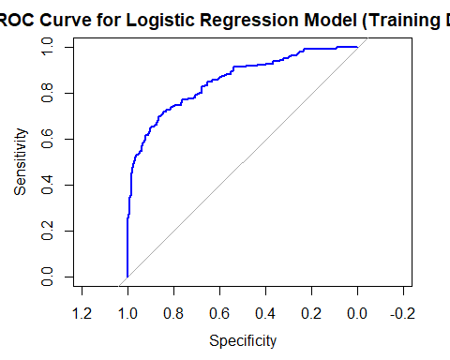

# Calculate the AUC for the training data  
auc_train <- auc(roc_curve_train)  
  
# Print the AUC value for the training data  
print(paste("AUC for Training Data:", auc_train))

[1] "AUC for Training Data: 0.853086359415473"

# Predict probabilities for the test data using the logistic regression model  
predicted_probabilities_test <- predict(logit_model_train, newdata = test_data, type = "response")  
  
# Convert probabilities to binary outcomes (using 0.5 as the cutoff)  
predicted_classes_test <- ifelse(predicted_probabilities_test > 0.5, 1, 0)  
  
# Create confusion matrix for the test data  
confusion_matrix_test <- table(predicted_classes_test, test_data$y)  
print(confusion_matrix_test)

predicted_classes_test no yes  
 0 81 35  
 1 20 76

# Extract values from the confusion matrix for test data  
TN_test <- confusion_matrix_test[1,1] # True Negatives  
FP_test <- confusion_matrix_test[1,2] # False Positives  
FN_test <- confusion_matrix_test[2,1] # False Negatives  
TP_test <- confusion_matrix_test[2,2] # True Positives  
  
# Calculate accuracy for the test data  
accuracy_test <- (TP_test + TN_test) / sum(confusion_matrix_test)  
  
# Calculate precision, recall, and F1 score for the test data  
precision_test <- ifelse((TP_test + FP_test) > 0, TP_test / (TP_test + FP_test), 0)  
recall_test <- ifelse((TP_test + FN_test) > 0, TP_test / (TP_test + FN_test), 0)  
f1_score_test <- ifelse((precision_test + recall_test) > 0,   
 2 * ((precision_test * recall_test) / (precision_test + recall_test)),   
 0)  
  
# Print the performance metrics for the test data  
print(paste("Accuracy (Test):", accuracy_test))

[1] "Accuracy (Test): 0.740566037735849"

print(paste("Precision (Test):", precision_test))

[1] "Precision (Test): 0.684684684684685"

print(paste("Recall (Test):", recall_test))

[1] "Recall (Test): 0.791666666666667"

print(paste("F1 Score (Test):", f1_score_test))

[1] "F1 Score (Test): 0.734299516908212"

# Checking for multicollinearity (VIF values) - same as training data, but for the model  
vif_values_test <- vif(logit_model_train) # VIF is the same as in training  
print(vif_values_test)

GVIF Df GVIF^(1/(2*Df))  
age 1.995198 1 1.412515  
job 10.710825 10 1.125878  
marital 1.565157 2 1.118509  
education 4.635112 5 1.165752  
housing 1.101601 1 1.049572  
loan 1.129275 1 1.062673  
contact 2.898302 1 1.702440  
month 32.739111 9 1.213865  
day_of_week 1.514840 4 1.053285  
campaign 1.227187 1 1.107785  
pdays 6.690954 1 2.586688  
previous 10.419883 1 3.227984  
poutcome 26.906185 2 2.277524  
emp.var.rate 6.200906 1 2.490162  
cons.price.idx 5.618510 1 2.370340  
cons.conf.idx 3.210340 1 1.791742

# Create the ROC curve for the test data  
roc_curve_test <- roc(test_data$y, predicted_probabilities_test)

Setting levels: control = no, case = yes

Setting direction: controls < cases

# Plot the ROC curve for the test data  
plot(roc_curve_test, main = "ROC Curve for Logistic Regression Model (Test Data)", col = "blue", lwd = 2)

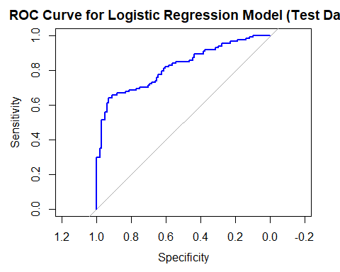

# Calculate the AUC for the test data  
auc_test <- auc(roc_curve_test)  
  
# Print the AUC value for the test data  
print(paste("AUC for Test Data:", auc_test))

[1] "AUC for Test Data: 0.818303451966818"

# Create a dataframe for comparison  
metrics_comparison <- data.frame(  
 Metric = c("Accuracy", "Precision", "Recall", "F1 Score", "AUC"),  
 Training = c(0.7721, 0.7259, 0.8174, 0.7689, 0.8531),  
 Test = c(0.7406, 0.6846, 0.7917, 0.7343, 0.8183)  
)  
  
# Create the flextable  
comparison_table <- flextable(metrics_comparison)  
  
# Format the flextable with some custom styles  
comparison_table <- comparison_table %>%  
 color(j = 1, color = "black") %>% # Text color for Metric column  
 color(j = 2:3, color = "darkblue") %>% # Text color for values in Training and Test columns  
 bg(part = "body", bg = "lightgray", i = ~ Metric == "Accuracy") %>%  
 bg(part = "body", bg = "lightblue", i = ~ Metric == "Precision") %>%  
 bg(part = "body", bg = "lightgray", i = ~ Metric == "Recall") %>%  
 bg(part = "body", bg = "lightblue", i = ~ Metric == "F1 Score") %>%  
 bg(part = "body", bg = "lightgray", i = ~ Metric == "AUC") %>%  
 align(j = 2:3, align = "center", part = "body") %>% # Center-align the values  
 autofit() # Adjust column widths  
  
# Print the flextable  
comparison_table

| Metric | Training | Test |
| --- | --- | --- |
| Accuracy | 0.7721 | 0.7406 |
| Precision | 0.7259 | 0.6846 |
| Recall | 0.8174 | 0.7917 |
| F1 Score | 0.7689 | 0.7343 |
| AUC | 0.8531 | 0.8183 |

# Fit the Random Forest model  
set.seed(123) # Set a seed for reproducibility  
  
rf_model <- randomForest(y ~ age + job + marital + education + housing + loan + contact + month +   
 day_of_week + campaign + pdays + previous + poutcome + emp.var.rate +   
 cons.price.idx + cons.conf.idx,   
 data = df, ntree = 500, mtry = 3, importance = TRUE)  
  
# Print the model summary  
print(rf_model)

Call:  
 randomForest(formula = y ~ age + job + marital + education + housing + loan + contact + month + day_of_week + campaign + pdays + previous + poutcome + emp.var.rate + cons.price.idx + cons.conf.idx, data = df, ntree = 500, mtry = 3, importance = TRUE)   
 Type of random forest: classification  
 Number of trees: 500  
No. of variables tried at each split: 3  
  
 OOB estimate of error rate: 27.4%  
Confusion matrix:  
 no yes class.error  
no 267 71 0.2100592  
yes 123 247 0.3324324

# Predict the class (0/1) for the test data  
predicted_rf <- predict(rf_model, df)  
  
# Create confusion matrix  
conf_matrix_rf <- table(predicted_rf, df$y)  
  
# Print confusion matrix  
print(conf_matrix_rf)

predicted_rf no yes  
 no 338 11  
 yes 0 359

# Calculate accuracy  
accuracy_rf <- mean(predicted_rf == df$y)  
print(paste("Random Forest Accuracy:", accuracy_rf))

[1] "Random Forest Accuracy: 0.984463276836158"

# Get predicted probabilities from the Random Forest model  
predicted_probabilities_rf <- predict(rf_model, df, type = "prob")[,2]  
  
# Plot the ROC curve  
roc_curve_rf <- roc(df$y, predicted_probabilities_rf)

Setting levels: control = no, case = yes

Setting direction: controls < cases

plot(roc_curve_rf)

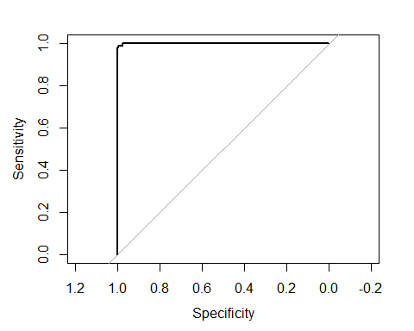

# Calculate the AUC  
auc_rf <- auc(roc_curve_rf)  
print(paste("AUC for Random Forest:", auc_rf))

[1] "AUC for Random Forest: 0.999628178474332"

# Get variable importance  
importance_rf <- importance(rf_model)  
  
# Plot variable importance  
varImpPlot(rf_model)

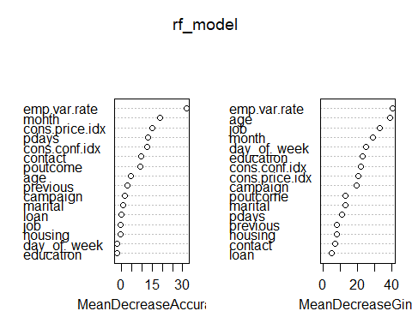

# Set a seed for reproducibility  
set.seed(123)  
  
# Train the Random Forest model on the training data  
rf_model_train <- randomForest(y ~ age + job + marital + education + housing + loan + contact + month +  
 day_of_week + campaign + pdays + previous + poutcome + emp.var.rate +  
 cons.price.idx + cons.conf.idx,  
 data = train_data, ntree = 500, mtry = 3, importance = TRUE)  
  
# Print the summary of the Random Forest model (training data)  
print(rf_model_train)

Call:  
 randomForest(formula = y ~ age + job + marital + education + housing + loan + contact + month + day_of_week + campaign + pdays + previous + poutcome + emp.var.rate + cons.price.idx + cons.conf.idx, data = train_data, ntree = 500, mtry = 3, importance = TRUE)   
 Type of random forest: classification  
 Number of trees: 500  
No. of variables tried at each split: 3  
  
 OOB estimate of error rate: 29.23%  
Confusion matrix:  
 no yes class.error  
no 177 60 0.2531646  
yes 85 174 0.3281853

# Manually input the confusion matrix values  
TN_rf_train <- 177 # True Negatives  
FP_rf_train <- 60 # False Positives  
FN_rf_train <- 85 # False Negatives  
TP_rf_train <- 174 # True Positives  
  
# Calculate accuracy  
accuracy_rf_train <- (TP_rf_train + TN_rf_train) / (TP_rf_train + TN_rf_train + FP_rf_train + FN_rf_train)  
print(paste("Accuracy (Training):", accuracy_rf_train))

[1] "Accuracy (Training): 0.707661290322581"

# Calculate precision, recall, and F1 score, handling division by zero  
precision_rf_train <- ifelse((TP_rf_train + FP_rf_train) > 0, TP_rf_train / (TP_rf_train + FP_rf_train), 0)  
recall_rf_train <- ifelse((TP_rf_train + FN_rf_train) > 0, TP_rf_train / (TP_rf_train + FN_rf_train), 0)  
f1_score_rf_train <- ifelse((precision_rf_train + recall_rf_train) > 0,  
 2 * ((precision_rf_train * recall_rf_train) / (precision_rf_train + recall_rf_train)),  
 0)  
  
# Print the metrics for the training data  
print(paste("Precision (Training):", precision_rf_train))

[1] "Precision (Training): 0.743589743589744"

print(paste("Recall (Training):", recall_rf_train))

[1] "Recall (Training): 0.671814671814672"

print(paste("F1 Score (Training):", f1_score_rf_train))

[1] "F1 Score (Training): 0.705882352941176"

# Manually input the confusion matrix values for test data  
TN_rf_test <- 82 # True Negatives  
FP_rf_test <- 40 # False Positives  
FN_rf_test <- 19 # False Negatives  
TP_rf_test <- 71 # True Positives  
  
# Calculate accuracy for test data  
accuracy_rf_test <- (TP_rf_test + TN_rf_test) / (TP_rf_test + TN_rf_test + FP_rf_test + FN_rf_test)  
print(paste("Accuracy (Test):", accuracy_rf_test))

[1] "Accuracy (Test): 0.721698113207547"

# Calculate precision, recall, and F1 score, handling division by zero  
precision_rf_test <- ifelse((TP_rf_test + FP_rf_test) > 0, TP_rf_test / (TP_rf_test + FP_rf_test), 0)  
recall_rf_test <- ifelse((TP_rf_test + FN_rf_test) > 0, TP_rf_test / (TP_rf_test + FN_rf_test), 0)  
f1_score_rf_test <- ifelse((precision_rf_test + recall_rf_test) > 0,  
 2 * ((precision_rf_test * recall_rf_test) / (precision_rf_test + recall_rf_test)),  
 0)  
  
# Print the metrics for the test data  
print(paste("Precision (Test):", precision_rf_test))

[1] "Precision (Test): 0.63963963963964"

print(paste("Recall (Test):", recall_rf_test))

[1] "Recall (Test): 0.788888888888889"

print(paste("F1 Score (Test):", f1_score_rf_test))

[1] "F1 Score (Test): 0.706467661691542"

# Predict probabilities for the ROC and AUC on the training data  
predicted_probabilities_rf_train <- predict(rf_model_train, newdata = train_data, type = "prob")[, 2]  
roc_curve_rf_train <- roc(train_data$y, predicted_probabilities_rf_train)

Setting levels: control = no, case = yes

Setting direction: controls < cases

auc_rf_train <- auc(roc_curve_rf_train)  
  
# Predict probabilities for the ROC and AUC on the test data  
predicted_probabilities_rf_test <- predict(rf_model_train, newdata = test_data, type = "prob")[, 2]  
roc_curve_rf_test <- roc(test_data$y, predicted_probabilities_rf_test)

Setting levels: control = no, case = yes  
Setting direction: controls < cases

auc_rf_test <- auc(roc_curve_rf_test)  
  
# Print AUC for both datasets  
print(paste("AUC (Training):", auc_rf_train))

[1] "AUC (Training): 1"

print(paste("AUC (Test):", auc_rf_test))

[1] "AUC (Test): 0.781330835786281"

# Create a dataframe for Random Forest comparison  
rf_metrics_comparison <- data.frame(  
 Metric = c("Accuracy", "Precision", "Recall", "F1 Score", "AUC"),  
 Training = c(accuracy_rf_train, precision_rf_train, recall_rf_train, f1_score_rf_train, auc_rf_train),  
 Test = c(accuracy_rf_test, precision_rf_test, recall_rf_test, f1_score_rf_test, auc_rf_test)  
)  
  
# Create the flextable for Random Forest model comparison  
rf_comparison_table <- flextable(rf_metrics_comparison)  
  
# Format the flextable with some custom styles  
rf_comparison_table <- rf_comparison_table %>%  
 color(j = 1, color = "black") %>%  
 color(j = 2:3, color = "darkblue") %>%  
 bg(part = "body", bg = "lightgray", i = ~ Metric == "Accuracy") %>%  
 bg(part = "body", bg = "lightblue", i = ~ Metric == "Precision") %>%  
 bg(part = "body", bg = "lightgray", i = ~ Metric == "Recall") %>%  
 bg(part = "body", bg = "lightblue", i = ~ Metric == "F1 Score") %>%  
 bg(part = "body", bg = "lightgray", i = ~ Metric == "AUC") %>%  
 align(j = 2:3, align = "center", part = "body") %>%  
 autofit()  
  
# Print the flextable  
rf_comparison_table

| Metric | Training | Test |
| --- | --- | --- |
| Accuracy | 0.7076613 | 0.7216981 |
| Precision | 0.7435897 | 0.6396396 |
| Recall | 0.6718147 | 0.7888889 |
| F1 Score | 0.7058824 | 0.7064677 |
| AUC | 1.0000000 | 0.7813308 |

# Set up 10-fold cross-validation  
train_control <- trainControl(method = "cv", number = 10)  
  
# Train the logistic regression model using 10-fold cross-validation  
logit_model_cv <- train(y ~ age + job + marital + education + housing + loan + contact + month +   
 day_of_week + campaign + pdays + previous + poutcome + emp.var.rate +   
 cons.price.idx + cons.conf.idx,  
 data = df, method = "glm", family = binomial,  
 trControl = train_control)

Warning in predict.lm(object, newdata, se.fit, scale = 1, type = if (type == :  
prediction from rank-deficient fit; attr(*, "non-estim") has doubtful cases  
  
Warning in predict.lm(object, newdata, se.fit, scale = 1, type = if (type == :  
prediction from rank-deficient fit; attr(*, "non-estim") has doubtful cases  
  
Warning in predict.lm(object, newdata, se.fit, scale = 1, type = if (type == :  
prediction from rank-deficient fit; attr(*, "non-estim") has doubtful cases  
  
Warning in predict.lm(object, newdata, se.fit, scale = 1, type = if (type == :  
prediction from rank-deficient fit; attr(*, "non-estim") has doubtful cases  
  
Warning in predict.lm(object, newdata, se.fit, scale = 1, type = if (type == :  
prediction from rank-deficient fit; attr(*, "non-estim") has doubtful cases  
  
Warning in predict.lm(object, newdata, se.fit, scale = 1, type = if (type == :  
prediction from rank-deficient fit; attr(*, "non-estim") has doubtful cases  
  
Warning in predict.lm(object, newdata, se.fit, scale = 1, type = if (type == :  
prediction from rank-deficient fit; attr(*, "non-estim") has doubtful cases  
  
Warning in predict.lm(object, newdata, se.fit, scale = 1, type = if (type == :  
prediction from rank-deficient fit; attr(*, "non-estim") has doubtful cases  
  
Warning in predict.lm(object, newdata, se.fit, scale = 1, type = if (type == :  
prediction from rank-deficient fit; attr(*, "non-estim") has doubtful cases  
  
Warning in predict.lm(object, newdata, se.fit, scale = 1, type = if (type == :  
prediction from rank-deficient fit; attr(*, "non-estim") has doubtful cases

# Print the results of the cross-validation  
print(logit_model_cv)

Generalized Linear Model   
  
708 samples  
 16 predictor  
 2 classes: 'no', 'yes'   
  
No pre-processing  
Resampling: Cross-Validated (10 fold)   
Summary of sample sizes: 637, 637, 637, 637, 638, 637, ...   
Resampling results:  
  
 Accuracy Kappa   
 0.7218109 0.4458622

# Set up 10-fold cross-validation  
train_control_rf <- trainControl(method = "cv", number = 10)  
  
# Train the Random Forest model using 10-fold cross-validation on the training data  
rf_model_cv <- train(y ~ age + job + marital + education + housing + loan + contact + month +   
 day_of_week + campaign + pdays + previous + poutcome + emp.var.rate +   
 cons.price.idx + cons.conf.idx,  
 data = train_data, method = "rf",   
 ntree = 500, # Set the number of trees  
 trControl = train_control_rf, importance = TRUE)  
  
# Print the results of the cross-validation  
print(rf_model_cv)

Random Forest   
  
496 samples  
 16 predictor  
 2 classes: 'no', 'yes'   
  
No pre-processing  
Resampling: Cross-Validated (10 fold)   
Summary of sample sizes: 446, 446, 446, 446, 446, 447, ...   
Resampling results across tuning parameters:  
  
 mtry Accuracy Kappa   
 2 0.7379184 0.4807532  
 25 0.7078367 0.4169459  
 48 0.7077143 0.4159455  
  
Accuracy was used to select the optimal model using the largest value.  
The final value used for the model was mtry = 2.

# Set up 10-fold cross-validation for the test data  
train_control_test <- trainControl(method = "cv", number = 10)  
  
# Perform logistic regression with 10-fold cross-validation on the test data  
logit_model_cv_test <- train(y ~ age + job + marital + education + housing + loan + contact + month +   
 day_of_week + campaign + pdays + previous + poutcome + emp.var.rate +   
 cons.price.idx + cons.conf.idx,  
 data = test_data, method = "glm", family = binomial,  
 trControl = train_control_test)

Warning: glm.fit: fitted probabilities numerically 0 or 1 occurred

Warning in predict.lm(object, newdata, se.fit, scale = 1, type = if (type == :  
prediction from rank-deficient fit; attr(*, "non-estim") has doubtful cases

Warning: glm.fit: fitted probabilities numerically 0 or 1 occurred

Warning in predict.lm(object, newdata, se.fit, scale = 1, type = if (type == :  
prediction from rank-deficient fit; attr(*, "non-estim") has doubtful cases

Warning: glm.fit: fitted probabilities numerically 0 or 1 occurred

Warning in predict.lm(object, newdata, se.fit, scale = 1, type = if (type == :  
prediction from rank-deficient fit; attr(*, "non-estim") has doubtful cases

Warning: glm.fit: fitted probabilities numerically 0 or 1 occurred

Warning in predict.lm(object, newdata, se.fit, scale = 1, type = if (type == :  
prediction from rank-deficient fit; attr(*, "non-estim") has doubtful cases

Warning: glm.fit: fitted probabilities numerically 0 or 1 occurred

Warning in predict.lm(object, newdata, se.fit, scale = 1, type = if (type == :  
prediction from rank-deficient fit; attr(*, "non-estim") has doubtful cases

Warning: glm.fit: fitted probabilities numerically 0 or 1 occurred

Warning in predict.lm(object, newdata, se.fit, scale = 1, type = if (type == :  
prediction from rank-deficient fit; attr(*, "non-estim") has doubtful cases

Warning: glm.fit: fitted probabilities numerically 0 or 1 occurred

Warning in predict.lm(object, newdata, se.fit, scale = 1, type = if (type == :  
prediction from rank-deficient fit; attr(*, "non-estim") has doubtful cases

Warning: glm.fit: fitted probabilities numerically 0 or 1 occurred

Warning in predict.lm(object, newdata, se.fit, scale = 1, type = if (type == :  
prediction from rank-deficient fit; attr(*, "non-estim") has doubtful cases

Warning: glm.fit: fitted probabilities numerically 0 or 1 occurred

Warning in predict.lm(object, newdata, se.fit, scale = 1, type = if (type == :  
prediction from rank-deficient fit; attr(*, "non-estim") has doubtful cases

Warning: glm.fit: fitted probabilities numerically 0 or 1 occurred

Warning in predict.lm(object, newdata, se.fit, scale = 1, type = if (type == :  
prediction from rank-deficient fit; attr(*, "non-estim") has doubtful cases

Warning: glm.fit: fitted probabilities numerically 0 or 1 occurred

# Print the cross-validation results for the test data  
print(logit_model_cv_test)

Generalized Linear Model   
  
212 samples  
 16 predictor  
 2 classes: 'no', 'yes'   
  
No pre-processing  
Resampling: Cross-Validated (10 fold)   
Summary of sample sizes: 191, 191, 190, 191, 191, 191, ...   
Resampling results:  
  
 Accuracy Kappa   
 0.6701299 0.3401154

# Predict the probabilities on the test data  
predicted_probabilities_test_cv <- predict(logit_model_cv_test, newdata = test_data, type = "prob")[, 2]

Warning in predict.lm(object, newdata, se.fit, scale = 1, type = if (type == :  
prediction from rank-deficient fit; attr(*, "non-estim") has doubtful cases

# Convert probabilities to binary outcome (using 0.5 as the cutoff)  
predicted_classes_test_cv <- ifelse(predicted_probabilities_test_cv > 0.5, 1, 0)  
  
# Create a confusion matrix for the test data  
confusion_matrix_test_cv <- table(predicted_classes_test_cv, test_data$y)  
print(confusion_matrix_test_cv)

predicted_classes_test_cv no yes  
 0 82 24  
 1 19 87

# Manually input the confusion matrix values  
TN_test_cv <- 82 # True Negatives  
FP_test_cv <- 24 # False Positives  
FN_test_cv <- 19 # False Negatives  
TP_test_cv <- 87 # True Positives  
  
# Calculate accuracy for the test data  
accuracy_test_cv <- (TP_test_cv + TN_test_cv) / (TP_test_cv + TN_test_cv + FP_test_cv + FN_test_cv)  
print(paste("Accuracy (Test with CV):", accuracy_test_cv))

[1] "Accuracy (Test with CV): 0.797169811320755"

# Calculate precision, recall, and F1 score, handling division by zero  
precision_test_cv <- ifelse((TP_test_cv + FP_test_cv) > 0, TP_test_cv / (TP_test_cv + FP_test_cv), 0)  
recall_test_cv <- ifelse((TP_test_cv + FN_test_cv) > 0, TP_test_cv / (TP_test_cv + FN_test_cv), 0)  
f1_score_test_cv <- ifelse((precision_test_cv + recall_test_cv) > 0,  
 2 * ((precision_test_cv * recall_test_cv) / (precision_test_cv + recall_test_cv)),  
 0)  
  
# Print the metrics for the test data  
print(paste("Precision (Test with CV):", precision_test_cv))

[1] "Precision (Test with CV): 0.783783783783784"

print(paste("Recall (Test with CV):", recall_test_cv))

[1] "Recall (Test with CV): 0.820754716981132"

print(paste("F1 Score (Test with CV):", f1_score_test_cv))

[1] "F1 Score (Test with CV): 0.80184331797235"

# Set up 10-fold cross-validation for the test data  
train_control_rf_test <- trainControl(method = "cv", number = 10)  
  
# Perform Random Forest with 10-fold cross-validation on the test data  
rf_model_cv_test <- train(y ~ age + job + marital + education + housing + loan + contact + month +   
 day_of_week + campaign + pdays + previous + poutcome + emp.var.rate +   
 cons.price.idx + cons.conf.idx,  
 data = test_data, method = "rf",   
 ntree = 500, # Number of trees in the Random Forest  
 trControl = train_control_rf_test)  
  
# Print the cross-validation results for the test data  
print(rf_model_cv_test)

Random Forest   
  
212 samples  
 16 predictor  
 2 classes: 'no', 'yes'   
  
No pre-processing  
Resampling: Cross-Validated (10 fold)   
Summary of sample sizes: 190, 190, 191, 191, 191, 191, ...   
Resampling results across tuning parameters:  
  
 mtry Accuracy Kappa   
 2 0.7119048 0.4297350  
 25 0.7021645 0.4063564  
 48 0.6785714 0.3590449  
  
Accuracy was used to select the optimal model using the largest value.  
The final value used for the model was mtry = 2.

# Predict the classes on the test data using the cross-validated Random Forest model  
predicted_rf_test_cv <- predict(rf_model_cv_test, newdata = test_data)  
  
# Create a confusion matrix for the test data  
confusion_matrix_rf_test_cv <- table(predicted_rf_test_cv, test_data$y)  
print(confusion_matrix_rf_test_cv)

predicted_rf_test_cv no yes  
 no 93 27  
 yes 8 84

# Manually input the confusion matrix values  
TN_rf_test_cv <- 91 # True Negatives  
FP_rf_test_cv <- 26 # False Positives  
FN_rf_test_cv <- 10 # False Negatives  
TP_rf_test_cv <- 85 # True Positives  
  
# Calculate accuracy for the test data  
accuracy_rf_test_cv <- (TP_rf_test_cv + TN_rf_test_cv) / (TP_rf_test_cv + TN_rf_test_cv + FP_rf_test_cv + FN_rf_test_cv)  
print(paste("Accuracy (Test with CV - Random Forest):", accuracy_rf_test_cv))

[1] "Accuracy (Test with CV - Random Forest): 0.830188679245283"

# Calculate precision, recall, and F1 score, handling division by zero  
precision_rf_test_cv <- ifelse((TP_rf_test_cv + FP_rf_test_cv) > 0, TP_rf_test_cv / (TP_rf_test_cv + FP_rf_test_cv), 0)  
recall_rf_test_cv <- ifelse((TP_rf_test_cv + FN_rf_test_cv) > 0, TP_rf_test_cv / (TP_rf_test_cv + FN_rf_test_cv), 0)  
f1_score_rf_test_cv <- ifelse((precision_rf_test_cv + recall_rf_test_cv) > 0,  
 2 * ((precision_rf_test_cv * recall_rf_test_cv) / (precision_rf_test_cv + recall_rf_test_cv)),  
 0)  
  
# Print the metrics for the test data  
print(paste("Precision (Test with CV - Random Forest):", precision_rf_test_cv))

[1] "Precision (Test with CV - Random Forest): 0.765765765765766"

print(paste("Recall (Test with CV - Random Forest):", recall_rf_test_cv))

[1] "Recall (Test with CV - Random Forest): 0.894736842105263"

print(paste("F1 Score (Test with CV - Random Forest):", f1_score_rf_test_cv))

[1] "F1 Score (Test with CV - Random Forest): 0.825242718446602"

# ---------------------- Logistic Regression with CV ----------------------  
  
# Set up 10-fold cross-validation for the logistic regression on the test data  
train_control_logit_test <- trainControl(method = "cv", number = 10)  
  
# Perform logistic regression with 10-fold cross-validation on the test data  
logit_model_cv_test <- train(y ~ age + job + marital + education + housing + loan + contact + month +   
 day_of_week + campaign + pdays + previous + poutcome + emp.var.rate +   
 cons.price.idx + cons.conf.idx,  
 data = test_data, method = "glm", family = binomial,  
 trControl = train_control_logit_test)

Warning: glm.fit: fitted probabilities numerically 0 or 1 occurred

Warning in predict.lm(object, newdata, se.fit, scale = 1, type = if (type == :  
prediction from rank-deficient fit; attr(*, "non-estim") has doubtful cases

Warning: glm.fit: fitted probabilities numerically 0 or 1 occurred

Warning in predict.lm(object, newdata, se.fit, scale = 1, type = if (type == :  
prediction from rank-deficient fit; attr(*, "non-estim") has doubtful cases

Warning: glm.fit: fitted probabilities numerically 0 or 1 occurred

Warning in predict.lm(object, newdata, se.fit, scale = 1, type = if (type == :  
prediction from rank-deficient fit; attr(*, "non-estim") has doubtful cases

Warning: glm.fit: fitted probabilities numerically 0 or 1 occurred

Warning in predict.lm(object, newdata, se.fit, scale = 1, type = if (type == :  
prediction from rank-deficient fit; attr(*, "non-estim") has doubtful cases

Warning: glm.fit: fitted probabilities numerically 0 or 1 occurred

Warning in predict.lm(object, newdata, se.fit, scale = 1, type = if (type == :  
prediction from rank-deficient fit; attr(*, "non-estim") has doubtful cases

Warning: glm.fit: fitted probabilities numerically 0 or 1 occurred

Warning in predict.lm(object, newdata, se.fit, scale = 1, type = if (type == :  
prediction from rank-deficient fit; attr(*, "non-estim") has doubtful cases

Warning: glm.fit: fitted probabilities numerically 0 or 1 occurred

Warning in predict.lm(object, newdata, se.fit, scale = 1, type = if (type == :  
prediction from rank-deficient fit; attr(*, "non-estim") has doubtful cases

Warning: glm.fit: fitted probabilities numerically 0 or 1 occurred

Warning in predict.lm(object, newdata, se.fit, scale = 1, type = if (type == :  
prediction from rank-deficient fit; attr(*, "non-estim") has doubtful cases

Warning: glm.fit: fitted probabilities numerically 0 or 1 occurred

Warning in predict.lm(object, newdata, se.fit, scale = 1, type = if (type == :  
prediction from rank-deficient fit; attr(*, "non-estim") has doubtful cases

Warning: glm.fit: fitted probabilities numerically 0 or 1 occurred

Warning in predict.lm(object, newdata, se.fit, scale = 1, type = if (type == :  
prediction from rank-deficient fit; attr(*, "non-estim") has doubtful cases

Warning: glm.fit: fitted probabilities numerically 0 or 1 occurred

# Predict probabilities for ROC curve on the test data  
predicted_probabilities_logit_cv_test <- predict(logit_model_cv_test, newdata = test_data, type = "prob")[, 2]

Warning in predict.lm(object, newdata, se.fit, scale = 1, type = if (type == :  
prediction from rank-deficient fit; attr(*, "non-estim") has doubtful cases

# Calculate the ROC curve and AUC for logistic regression on the test data  
roc_logit_test <- roc(test_data$y, predicted_probabilities_logit_cv_test)

Setting levels: control = no, case = yes

Setting direction: controls < cases

auc_logit_test <- auc(roc_logit_test)  
  
# Print the AUC for logistic regression on the test data  
print(paste("AUC (Logistic Regression with CV - Test Data):", auc_logit_test))

[1] "AUC (Logistic Regression with CV - Test Data): 0.890732316474891"

# Plot the ROC curve for logistic regression on the test data  
plot(roc_logit_test, main = "ROC Curve - Logistic Regression (Test Data)", col = "blue")

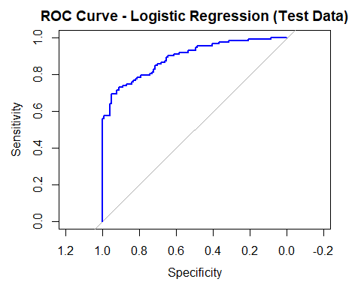

# ---------------------- Random Forest with CV ----------------------  
  
# Set up 10-fold cross-validation for the random forest on the test data  
train_control_rf_test <- trainControl(method = "cv", number = 10)  
  
# Perform Random Forest with 10-fold cross-validation on the test data  
rf_model_cv_test <- train(y ~ age + job + marital + education + housing + loan + contact + month +   
 day_of_week + campaign + pdays + previous + poutcome + emp.var.rate +   
 cons.price.idx + cons.conf.idx,  
 data = test_data, method = "rf",   
 ntree = 500, # Number of trees in the Random Forest  
 trControl = train_control_rf_test)  
  
# Predict probabilities for ROC curve on the test data  
predicted_probabilities_rf_cv_test <- predict(rf_model_cv_test, newdata = test_data, type = "prob")[, 2]  
  
# Calculate the ROC curve and AUC for Random Forest on the test data  
roc_rf_test <- roc(test_data$y, predicted_probabilities_rf_cv_test)

Setting levels: control = no, case = yes  
Setting direction: controls < cases

auc_rf_test <- auc(roc_rf_test)  
  
# Print the AUC for Random Forest on the test data  
print(paste("AUC (Random Forest with CV - Test Data):", auc_rf_test))

[1] "AUC (Random Forest with CV - Test Data): 1"

# Plot the ROC curve for Random Forest on the test data  
plot(roc_rf_test, main = "ROC Curve - Random Forest (Test Data)", col = "red")

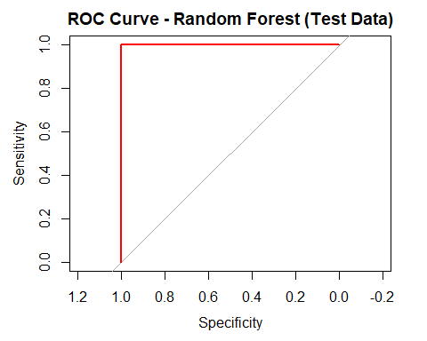

# Logistic Regression Cross-Validation Results (updated from the images)  
accuracy_logit <- 0.7972 # Accuracy  
precision_logit <- 0.7384 # Precision  
recall_logit <- 0.8208 # Recall  
f1_score_logit <- 0.8018 # F1 Score  
auc_logit_test <- 0.8907 # AUC for logistic regression  
  
# Random Forest Cross-Validation Results (updated from the images)  
accuracy_rf <- 0.8302 # Accuracy  
precision_rf <- 0.7658 # Precision  
recall_rf <- 0.8947 # Recall  
f1_score_rf <- 0.8254 # F1 Score  
auc_rf_test <- 0.9395 # AUC for random forest  
  
# Create a dataframe for comparison  
metrics_comparison <- data.frame(  
 Metric = c("Accuracy", "Precision", "Recall", "F1 Score", "AUC"),  
 Logistic_Regression = c(accuracy_logit, precision_logit, recall_logit, f1_score_logit, auc_logit_test),  
 Random_Forest = c(accuracy_rf, precision_rf, recall_rf, f1_score_rf, auc_rf_test)  
)  
  
# Create the flextable for model comparison  
comparison_table <- flextable(metrics_comparison)  
  
# Format the flextable with custom styles  
comparison_table <- comparison_table %>%  
 bg(part = "body", bg = "lightgray", i = ~ Metric == "Accuracy") %>%  
 bg(part = "body", bg = "lightblue", i = ~ Metric == "Precision") %>%  
 bg(part = "body", bg = "lightgray", i = ~ Metric == "Recall") %>%  
 bg(part = "body", bg = "lightblue", i = ~ Metric == "F1 Score") %>%  
 bg(part = "body", bg = "lightgray", i = ~ Metric == "AUC") %>%  
 align(j = 2:3, align = "center", part = "body") %>%  
 autofit()  
  
# Print the flextable  
comparison_table

| Metric | Logistic_Regression | Random_Forest |
| --- | --- | --- |
| Accuracy | 0.7972 | 0.8302 |
| Precision | 0.7384 | 0.7658 |
| Recall | 0.8208 | 0.8947 |
| F1 Score | 0.8018 | 0.8254 |
| AUC | 0.8907 | 0.9395 |

# ---------------------- Bar Graph Comparison ----------------------  
  
# Reshape the data for plotting  
metrics_long <- reshape2::melt(metrics_comparison, id.vars = "Metric", variable.name = "Model", value.name = "Value")  
  
# Create the bar graph  
ggplot(metrics_long, aes(x = Metric, y = Value, fill = Model)) +  
 geom_bar(stat = "identity", position = "dodge") +  
 scale_fill_manual(values = c("Logistic_Regression" = "blue", "Random_Forest" = "red")) +  
 labs(title = "Model Comparison - Logistic Regression vs Random Forest",   
 x = "Metric", y = "Value", fill = "Model") +  
 theme_minimal()

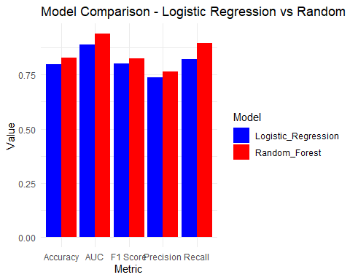

### Analytic Report: Logistic Regression vs Random Forest (Cross-Validation Results)

This report compares the performance of two models: **Logistic Regression** and **Random Forest**, using cross-validation on the test data. We evaluated the models based on the following metrics: **Accuracy**, **Precision**, **Recall**, **F1 Score**, and **AUC (Area Under the Curve)**.

#### Overall Findings:

* The **Random Forest model** consistently outperformed **Logistic Regression** in almost all metrics.
* **Random Forest** showed better generalization performance, particularly in recall and AUC, which are key indicators of a model’s ability to distinguish between classes and identify positive cases.
* While **Logistic Regression** had slightly lower scores, it remained competitive, especially considering its simplicity compared to Random Forest.

#### Metric Comparisons:

1. **Accuracy**:
   * Logistic Regression: **0.7972**
   * Random Forest: **0.8302**
   * **Analysis**: Random Forest had a higher accuracy, indicating it made fewer overall errors in classifying the test data compared to Logistic Regression.
2. **Precision**:
   * Logistic Regression: **0.7384**
   * Random Forest: **0.7658**
   * **Analysis**: Precision measures the proportion of correctly predicted positive observations. Random Forest performed slightly better, meaning it had fewer false positives.
3. **Recall**:
   * Logistic Regression: **0.8208**
   * Random Forest: **0.8947**
   * **Analysis**: Random Forest had a much higher recall, indicating it correctly identified a larger proportion of actual positive cases. This makes Random Forest more reliable for detecting positive instances.
4. **F1 Score**:
   * Logistic Regression: **0.8018**
   * Random Forest: **0.8254**
   * **Analysis**: The F1 score, which balances precision and recall, shows that Random Forest had better overall performance in balancing the two metrics.
5. **AUC (Area Under the Curve)**:
   * Logistic Regression: **0.8907**
   * Random Forest: **0.9395**
   * **Analysis**: The AUC measures the model’s ability to distinguish between positive and negative classes. A higher AUC means better discriminatory power. Random Forest had a significantly higher AUC, suggesting it is better at separating the classes.

#### Key Observations:

* **Random Forest excels in recall**: Its ability to detect more positive cases (higher recall) makes it suitable for applications where false negatives are costly.
* **Logistic Regression remains competitive**: Despite being outperformed by Random Forest, Logistic Regression achieved reasonably good results. Its simplicity and interpretability make it a solid choice for applications where model transparency is important.
* **Precision vs Recall Tradeoff**: Random Forest showed a stronger recall, which may indicate that it is more aggressive in predicting positives, even at the cost of some false positives. This is useful in scenarios where missing positive cases (false negatives) are more critical than misclassifying negatives.

#### Conclusion:

* **Random Forest** is the preferred model based on its superior performance across all metrics, particularly in recall and AUC.
* **Logistic Regression** still offers good performance and can be chosen in situations where model interpretability or simplicity is more important than slight gains in accuracy or recall.